**Pre-Calculus**

**Unit 1 – August 23 to September 9**

|  |  |  |
| --- | --- | --- |
| **Date** | **Topic** | **Assignment** |
| Tues  8/23 | Review |  |
| Wed  8/24 | 4.1 - Radian and Degree Measure | P.290 (7-19 odd, 31-41 odd, 47-54 all) |
| Thurs  8/25 | 4.1 - Radian and Degree Measure | Worksheet |
| Fri  8/26 | 4.1 - Radian and Degree Measure | P.290 (83-93 odd, 101-104) |
| Mon  8/29 | 4.2 - Unit Circle Project | Paper Plate Project |
| Tues  8/30 | 4.2 - Unit Circle | Paper Plate Project + Unit Circle part 1 |
| Wed  8/31 | 4.2 - Unit Circle | Unit Circle part 2 |
| Thur  9/1 | 4.3 - Right Triangle Trig | P.308 (1-4, 11-14, 17-27) |
| Fri  9/2 | 4.4 - Trig Functions of Any Angle | P. 318 (1-7 odd, 11-14, 15, 17, 21, 23, 29-36) |
| Tues  9/6 | 4.4 - Trig Functions of Any Angle | P.318 (37 - 87 every other odd) |
| Wed  9/7 | 4.4 - Trig Functions of Any Angle | Workday. Finish problems and get review. |
| Thurs  9/8 | Review - Test 1.3 | Study!! |
| Fri  9/9 | Test |  |

**Thursday, August 25 - Angles and Radian Measures**

**Change each degree measure to radian measure in terms of .**

1)  2)  3)  4)  5)  6) 

**Change each radian measure to degree measure. Round to the nearest tenth if necessary.**

7)  8)  9)  10)  11)  12) 

**Convert the given degree into DMS or the DMS into degree.**

13)  14)  15)  16) 

**Tuesday, August 30 - Unit Circle part 1**

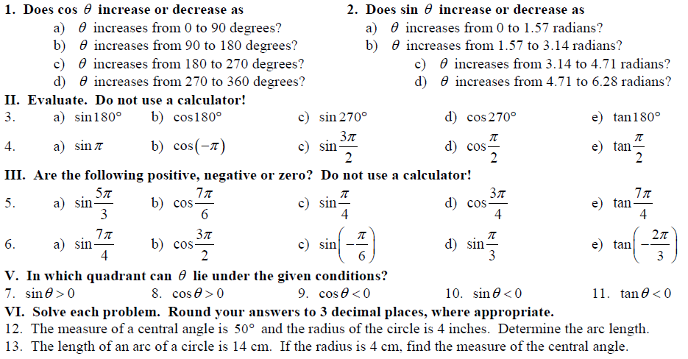

**Wednesday, August 31** **- Unit Circle part 2**

